High Level Registration Documentation

Log In – Located at the bottom of the main website footer

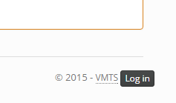

To work with class registrations click the “Registrations” tab



Choose a class to view registrations

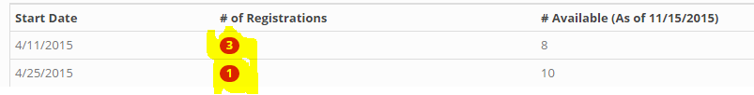

To update the confirmation status click the “thumbs down” icon.

To update the payment processed status click the “information” icon.

You can choose to View, Print, or Export the record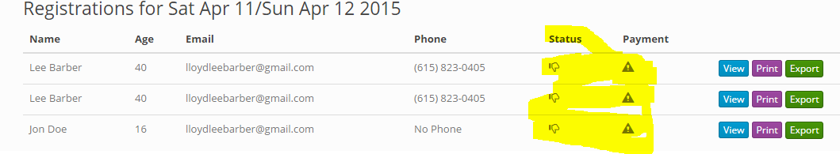

The export function will save the record as a CSV file on the server for you to download to your computer then upload to the state of TN web site.